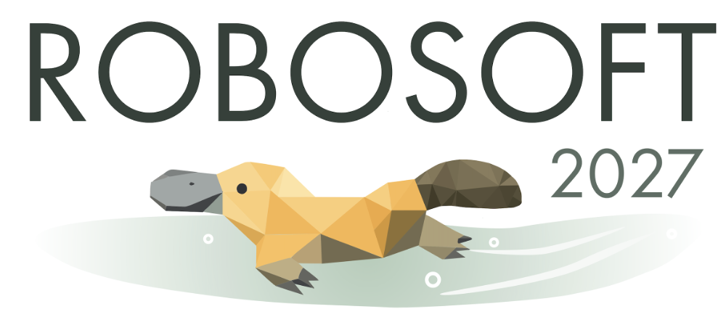
Brisbane, Australia
WORKSHOP/TUTORIAL PROPOSAL
[Full/half day]
(Template and instructions provided to help you prepare the submission, red text should be deleted in submission. Editable template will be made available closer to the submission date once it is checked for formatting)
TITLE: …

ORGANIZERS
# | Name | Affiliation and Email
1 |  | University…  Email: …@
2
3
We encourage early career researchers and a focus on diversity as organizers. 2-4 organizers is a common number.
- Please delete notes (in red) when submitting the proposal

ABSTRACT
(250 words maximum. This abstract will be displayed on the RoboSoft homepage; therefore, please be concise and catchy. We encourage you to propose a workshop in line with the theme of the conference “Soft Robots in the Wild” and describe any innovative or interactive aspects of your planned workshop to attract additional interest.)

DESCRIPTION
(500 words maximum. Describe the background and the objectives of this workshop/tutorial)

TOPICS OF INTEREST
(Provide a list of topics (keywords, up to 10) addressed in the workshop.)

INVITED SPEAKERS
(Note confirmed and unconfirmed status. We encourage having informed all the speakers before listing them and receiving confirmation by at least half of them. While the scientific topic match is important, kindly consider the balance in terms of nationality, gender, and career stage when selecting speakers. Giving a voice to new community members will be appreciated, so we have asked you to confirm with speakers how many workshops they have already or are planning to commit to.)
# | Name | Affiliation | Status (Confirmed?) | Career Stage | Number of other workshop commitments

TENTATIVE SCHEDULE
(Provide a tentative program for the workshop, as detailed as possible (name of sessions, activity/invited talks’ length, discussion time slots, and so on. Please consider that the half-day workshop for 4 hours with coffee break, the full day workshop will run for 7 hours, lunch is not provided)

TIME | DESCRIPTION | TOPIC

PLAN TO ENCOURAGE INTERACTION AMONG PARTICIPANTS and SOLICIT PARTICIPATION
(500 words maximum. Indicate how to structure your workshop/tutorial to maximize discussion among attendees and to solicit participation.

PREVIOUS SIMILAR ROBOTICS WORKSHOPS AND THEIR ATTENDANCE (if applicable)
(200 words maximum. Details on previously held robotics workshops on a similar topic. Similarities and differences between your proposal and those previous workshops. Number of attendees at these previous workshops)

EQUIPMENT NEEDS
(Anything needed besides a projector and screen, such as poster stands or tables. Any additional/specialized equipment needs will have to be addressed by the workshop organizers.)

SPONSORSHIP (if applicable)
(Organizers are encouraged to find financial support for better organizing the workshop/tutorial, such as poster presentation awards, lunch, and travel support. Also, endorsements from committees (other than TC on Soft Robotics) can be included if the workshop is also relevant to other topics. Since the workshop is already planned for RoboSoft, an endorsement letter from TC on Soft Robotics is neither required, nor will it be considered.)

ADDITIONAL INFORMATION (if applicable)
(Feel free to add any other information at the end to help us evaluate your proposal. 300 words maximum)

